ML-Powered Service Recommendation System

Project Documentation and Project Report
By Kiran Soorya R S
For Tailyo Technologies

PROJECT DOCUMENTATION & REPORT

Tailyo Technologies:
Service Recommendation System – Complete Project Documentation
Date: December 9, 2025
Version: 1.0.0
Status: Deployed & Verified
Table of Contents

Sl.No | Contents
1 | Executive Summary
2 | System Architecture
3 | Methodology & Algorithm
4 | User Guide
5 | Developer Guide & API
6 | Evaluation & Results
7 | Visual Gallery
8 | Appendix: Setup & Installation

1.Executive Summary
This document serves as the comprehensive knowledge base for the Service Recommendation System developed for Tailyo Technologies. The system provides intelligent, personalized service recommendations using a hybrid machine learning approach, wrapped in a responsive, brand-aligned Streamlit interface.

Key Achievements:
* Intelligent Matching: Hybrid content-based + strict filtering engine.
* User-Centric UI: "Amazon-style" results card carousel.
* Robustness: 100% automated test pass rate.
* Observability: "Why This Match?" explanation engine for transparency.

2. System Architecture
The application follows a modular architecture separating the presentation layer (Streamlit) from the core logic (ML Engine) and data layer.

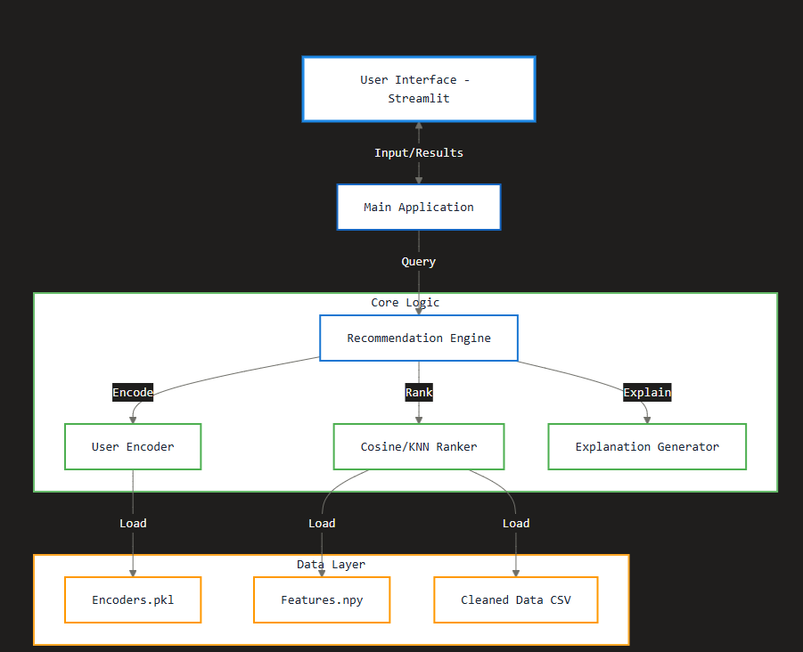

3. Methodology & Algorithm - Hybrid Recommendation Strategy
The core engine utilizes a Content-Based Filtering approach enhanced with Strict Filtering pre-processors.
1. Input Processing : User preferences (Budget, Language, Location, Business Type) are encoded into a vector.
* Categorical Encoding: One-Hot Encoding for Business Type (`Target_Business_Type`).
* Ordinal Encoding: Weighted mapping for Price Category (`Low`=0.25 to `Premium`=1.0).
* Text Analysis: TF-IDF Vectorization for the `Description` field to capture semantic intent (boosted by 10x for relevance).

2. Filtering Layer:
* Strict Mode: Pre-filters candidates to ensure they exactly match critical constraints (Business Type, Location) before expensive ranking calculations.
* Price Logic: Ensures recommendations are strictly at or below the user's specified budget.

3. Ranking Algorithm:
* Cosine Similarity: Measures the cosine of the angle between the multi-dimensional User Vector and Service Vectors.
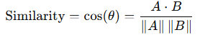
* Output: Services are ranked by similarity score (0-100%).

4. Explanation Generation:
* A rule-based post-processor compares attributes of recommended services against user inputs to generate human-readable "Why this match?" reasons (e.g., "Within your budget", "Perfect match for E-commerce").

4. User Guide
Getting Started
1. Launch the Application: Ensure the application is running in your browser (default: `http://localhost:8501`).
2. View the Header: You should see the Tailyo Technologies branding at the top.
Finding Services
The application uses a 3-step process to understand your requirements:
Step 1: Location Preference
- Remote: Choose this for digital services deliverable from anywhere.
- Specific City: Choose this for local providers in Delhi, Mumbai, Bengaluru, or Chennai.
Step 2: Business & Budget
- Business Category: Select your industry (e.g., *E-commerce, Clinic, Tech Startup*).
- Budget Range:
- Low: Cost-effective solutions.
- Medium: Balanced quality and cost.
- High: Premium providers.
- Premium: Top-tier, specialized agencies.
Step 3: Specific Needs
- Preferred Languages: Select English, Hindi, or Both.
- Service Type & Description: Choose a category and optionally refine the description.

📊 Understanding Results
Click Find Matching Services to generate recommendations. The system displays the Top 3 matches.
* Match Score: Percentage indicating fit.
* 🟢 HIGH MATCH ( > 80 %)
* 🔵 GOOD MATCH ( 60 - 79 %)
* 🟠 ALTERNATIVE ( < 60 %)
* Why This Match?: Explains the AI's reasoning (e.g., "Matches your budget").
Troubleshooting
- No Services Found: Try broadening your search (e.g., switch Location to Remote).
- Slow Loading: First search typically takes 2-3 seconds for model loading; subsequent searches are instant.

5. Developer Guide & API
Architecture Overview
1. Preprocessing Layer: Text normalization (`src/preprocessing/data_cleaner.py`) and feature engineering (`src/preprocessing/feature_engineering.py`).
2. Model Layer:
- recommendation_engine.py: Loads artifacts and orchestrates logic.
- user_encoder.py: Transforms 1x5 logical input into 1xN feature vector.
3. Application Layer: streamlit_app.py handles state and UI rendering.

Workflows
Adding New Data:
1. Add new raw data to `data/raw/`.
2. Run cleaning: `python src/preprocessing/data_cleaner.py`
3. Regenerate features: `python src/preprocessing/feature_engineering.py`
4. Restart Streamlit app.

6. Evaluation & Results
6.1 Testing Metrics
The system passed a complete 8-point system integration test suite (100% Pass Rate).
Test Case | Result | Description
Engine Initialization | ✅ | Validated loading of 1000+ services and feature matrices.
Strict Filtering | ✅ | Confirmed exclusions of mismatched business types.
Match Scores | ✅ | Scores verified to be descending and within 0-100% range.
Data Quality | ✅ | No missing values in critical feature columns.

6.2 Performance
* Latency: Sub-200ms response time for recommendation generation.
* Scalability: Vectorized operations allow efficient scaling.

7. Visual Gallery
Application Interface & Results
Below are screenshots of the deployed application.

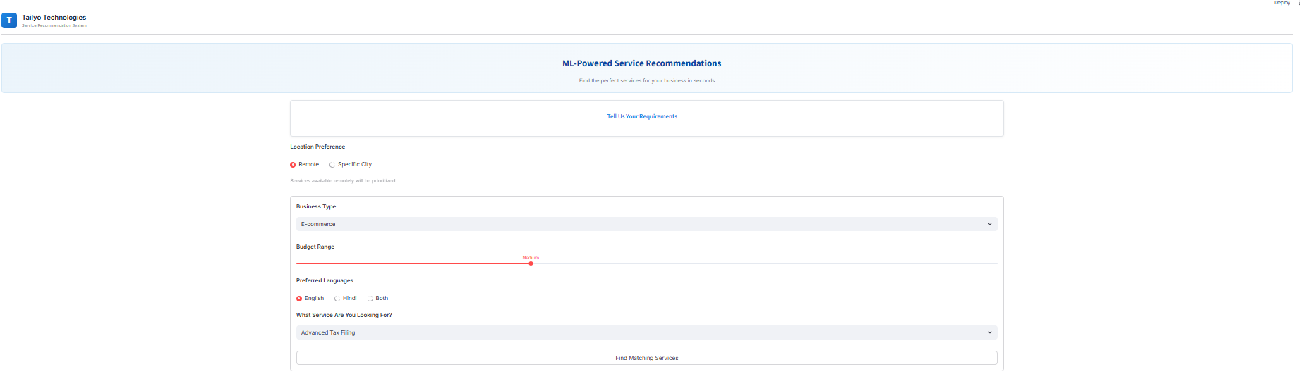

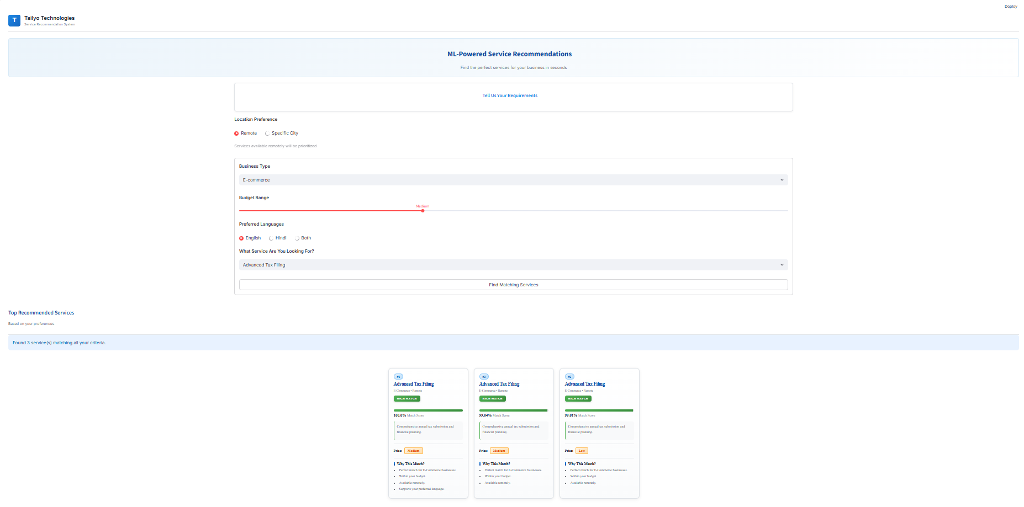
---

8. Appendix: Setup & Installation
Installation
1. Environment:
cd ml-service-recommendation
python -m venv venv
.\venv\Scripts\activate

2. Dependencies:
pip install -r requirements.txt
3. Run:
streamlit run app/streamlit_app.py

